**CALL TO TEST**

**When you are testing book a flight function, you will need the login test case**

**When you are testing a purchase function, you will need the login test case again**

**So, in this situation, you don’t have to rewrite the login testcase each time**

**You can just call to the login test**

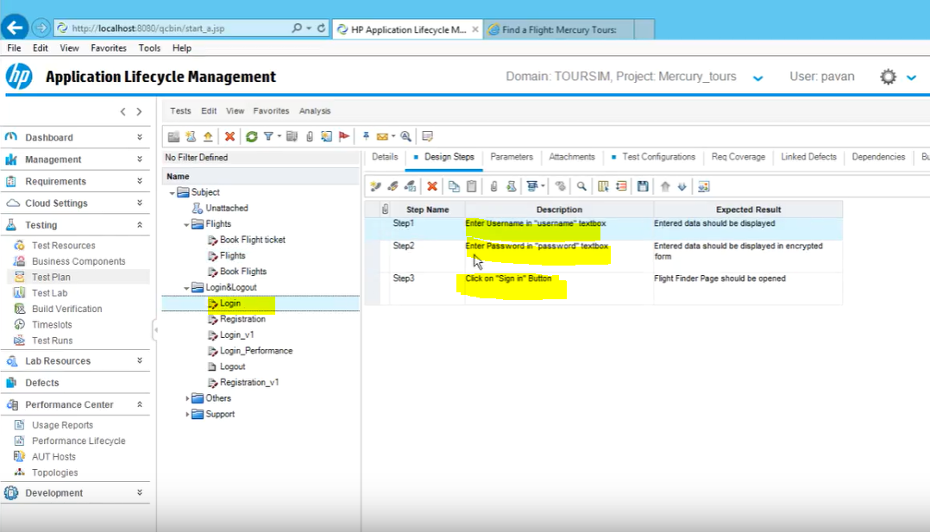

**We wrote the Login test case once,**

**So next time we need it, we can use “Call to Test” icon and copy this to the other test case we need this in**

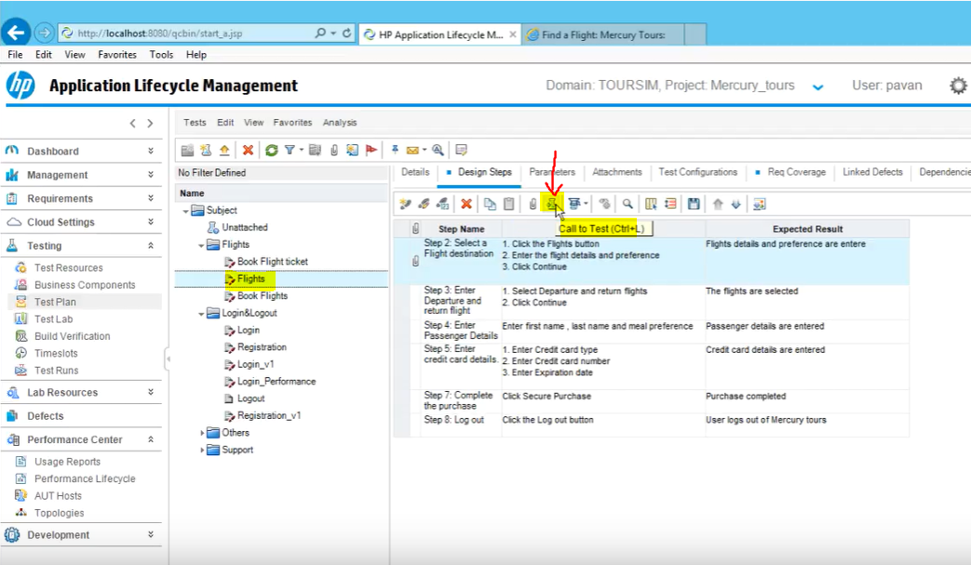

**Then we select the test case we want to bring in**

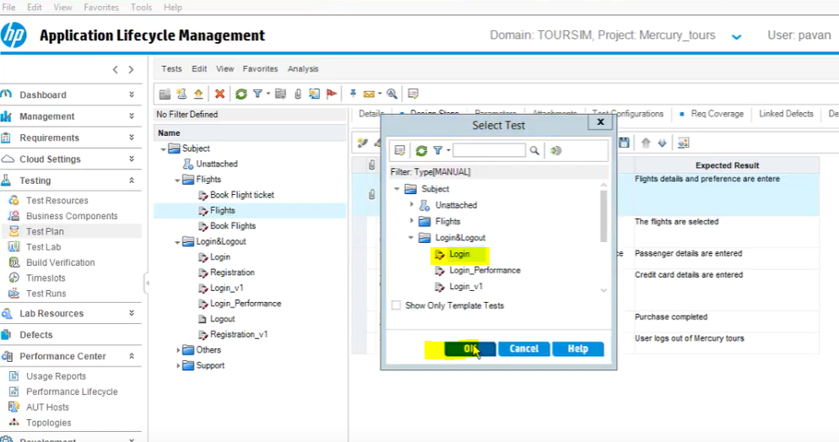

**Click ok**

